Golden Empire Patch Programs
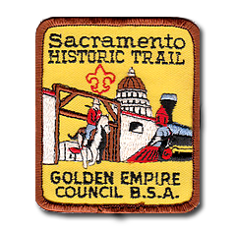 | Sacramento Historic Trail  This is a one-day 5 mile urban hike to remember and experience the  California Gold Rush in Sacramento.  Requirements:  - Hike the trail as shown on the map in the Trail guide from Sutter's  Fort to Old Sacramento and return (about 5 miles).  - Visit the State Capital (admission is free) and the State Railroad  Museum (admission is charged).  - A visit to Sutter's Fort is recommended. Admission is charged.
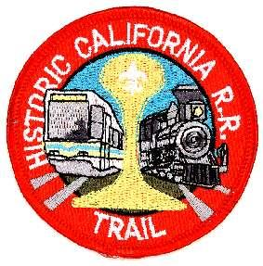 | Historic California R.R. Trail  Requirements:  - Take light rail using the Blue line (Watt 1-80 - Cosumnes River  College), the Gold line (Folsom) or the Green line  (Richards/Township 9) to downtown.  - Visit the California State Railroad Museum (admission required).

The patch for the Sacramento Historic Trail may be purchased at the River City Scout Shop. Contact the Scout shop at 916 649-1800. The Historic California R.R. Trail may be purchased at the Council Office.

